**Lab #8**

**Part 1**

The code for the plot #1 and plot #2 is the following:

m=[];

f=400;

x=linspace(0,10,501);

t=linspace(0,180,401);

for i_t=1:length(t)

for i_x=1:length(x)

m(i_t,i_x)=(f*sin(t(i_t)*(pi/180))*3)+(f*cos(t(i_t)*(pi/180))*x(i_x));

end

end

grid on

hold on

plot(x,m(1,:));

plot(x,m(201,:));

plot(x,m(301,:));

plot(x,m(401,:));

xlabel('x (m)')

ylabel('Moment at A (N m)')

label1=sprintf('%s=%2.1f%','\theta',t(1),'\circ');

label2=sprintf('%s=%2.1f%s','\theta',t(201),'\circ');

label3=sprintf('%s=%2.1f%s','\theta',t(301),'\circ');

label4=sprintf('%s=%2.1f%s','\theta',t(401),'\circ');

title('Moment vs X')

legend('\theta=0°','\theta=90°','\theta=135°','\theta=180°')

grid on

hold off

figure

hold on

grid on

plot(t,m(:,1));

plot(t,m(:,201));

plot(t,m(:,301));

plot(t,m(:,401));

xlabel('\theta (degrees)');

ylabel('Moment at A (N m)')

label5=sprintf('x= %2.1fm',x(1));

label6=sprintf('x= %2.1fm',x(201));

label7=sprintf('x= %2.1fm',x(301));

label8=sprintf('x= %2.1fm',x(401));

legend(label5,label6,label7,label8);

title('Moment vs Theta')

The code above produces the following graphs:

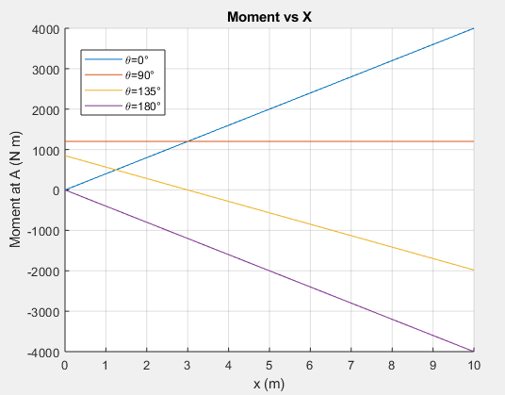

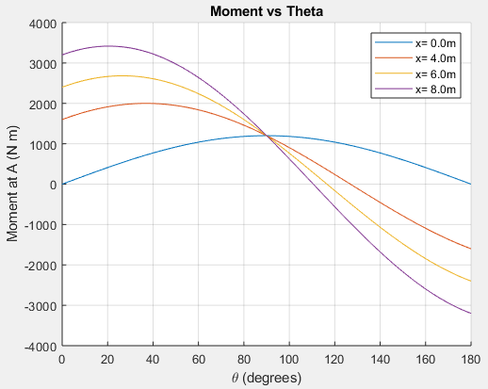

**Part 2**

Edge and Special Case Considerations

1. Our results make sense for when θ=90°. This is because when θ=90°, the force is in the vertical direction and has no horizontal component. At that point, the perpendicular distance from the force to point A would be the same for all the x distances. This means that the Moment about A would be the same for all x distances and our graph proves this as well.
2. Our results make sense when x=0 as θ varies because if θ=0° when x=0, then the line of action of the force would pass through A and hence, the moment about A would be 0. As θ increases from 0°-90°, the vertical component of the force increases and the horizontal component decreases. As a result, this would increase the moment about A and our graph shows that. At θ=90°, the entire force would be vertical so the maximum moment about A would be reached. As θ increases from 90°-180°, the vertical component of the force decreases, and the horizontal component of the force increases. This results in the moment about A decreasing since there is less force acting vertically and more horizontally. Finally, at θ=180°, the line of action of the force would pass through point A, and hence the Moment about A would be 0. All the cases for when θ=0°-180° makes sense theoretically and our graph proves them as well.
3. As x increases, our result makes sense. In our graph, as x increases, the maximum moment begins to occur at a smaller and decreasing θ. This is because at points when the perpendicular distance from the force reaches point A, the maximum moment occurs. For example, at x=0, for the force to have a perpendicular distance to A, θ must be 90°. As x begins to increase, for the force to have a perpendicular distance to A, θ will be smaller. Reaching higher and higher heights would mean a smaller angle of θ would result in a perpendicular distance from the force that leads directly to point A. Hence, on our graph, the maximum moment for the varying x distances occur at smaller values of θ for higher values of x.

Interpreting Results

1. For the moment at A to be completely independent of x, I would have the force so that θ=90°, This is because the entire force is vertical and perpendicular to A. With θ=90°, only the horizontal distance from the force to A is used, so it does not matter what x is.
2. For the moment at A to be 0, x would have to be 0m, and θ would have to be either 0° or 180°. At x=0, the force would be horizontally in line with A, and with a θ of either 0° or 180°, the line of action of the force would be crossing A, resulting in a moment of 0.